Technical Design Document
PAF Test Assignment

Alekhya Singisetty

Table of Contents
1 Introduction 3
1.1 Purpose 3
1.2 Functional description 3
1.3 Assumptions 3
1.4 Language Specification 3
1.5 UML Diagrams 4

Introduction

Purpose
The purpose of this document is to outline the technical design of the Zoo system provide an overview for the animals in Zoo and their details and live one day of implementation.
Its main purpose is to -
- Display list of all animals in zoo with their properties and friends' names.
- Live one day and display of every animal's break/establish friendship.
- Exit.

Functional description
- All animals live in a Zoo.
- Animals are divided as Mammals and Birds, where Dogs are mammals and Chicken and Parrot are birds.
- Each animal can have several friends among other animal from the zoo.
- Every day each animal loses a friend if there are any and gets from zero to one new friend.
- If A is a friend of B then B is a friend of A which implies when A loses friendship with B then B also loses friendship with A.
- Display of animals and their properties and friends followed by the description of break/establish friendship of each day based on user input.
- When there are no friends of an animal it is displayed in console as Nil.

Assumptions
- Animal can be a friend of any other animal of same or different kind.
- A loses friendship with B then B also loses friendship with A.

Language Specification
Programing language : Java 1.8.0_91
Testing : JUnit4
IDE : Eclipse Jee Mars

UML Diagrams

Class Diagram

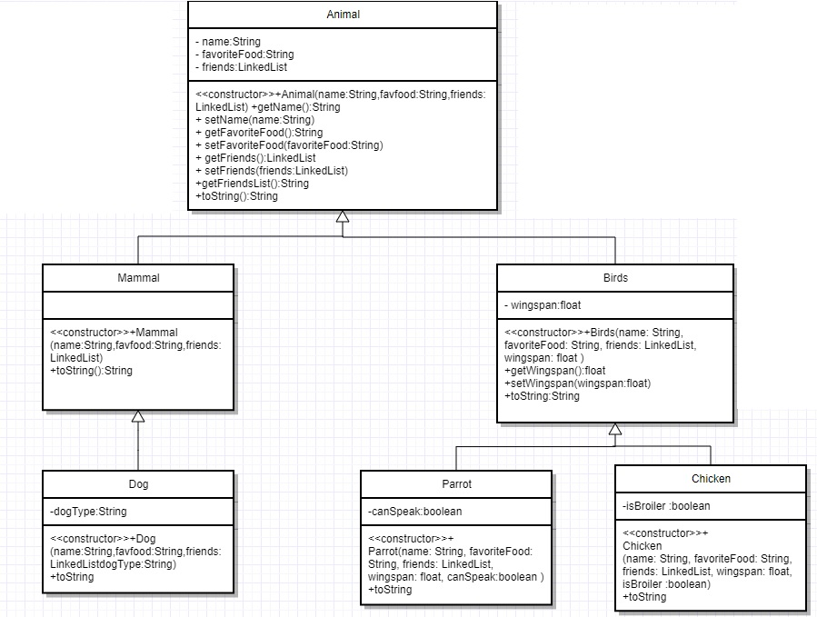

Flow Chart

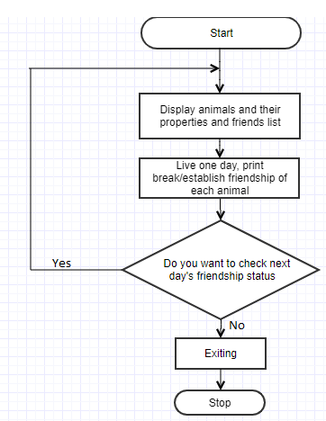

Display of output in console(Screens):

Day 1

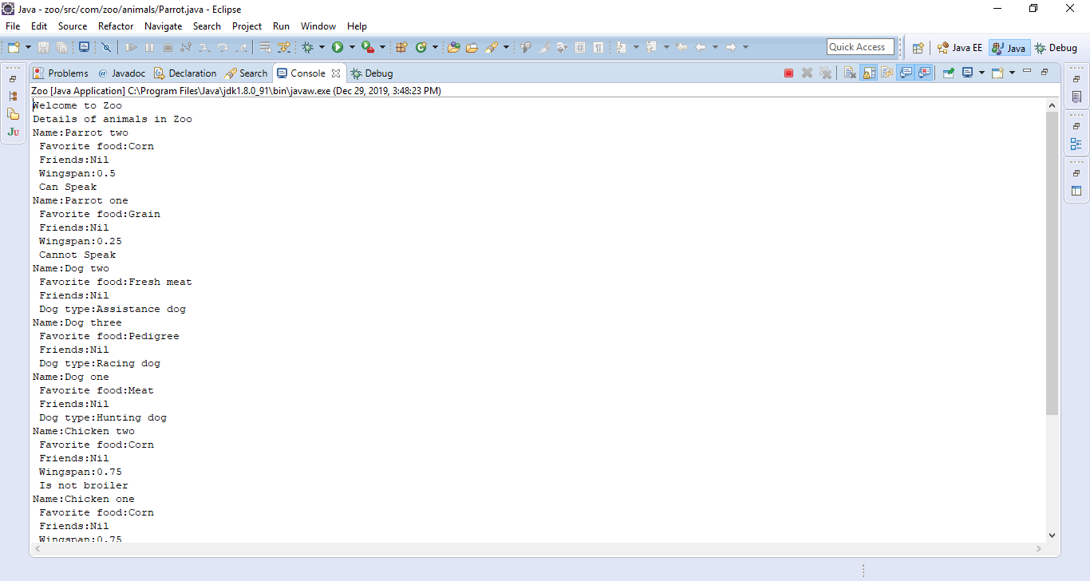

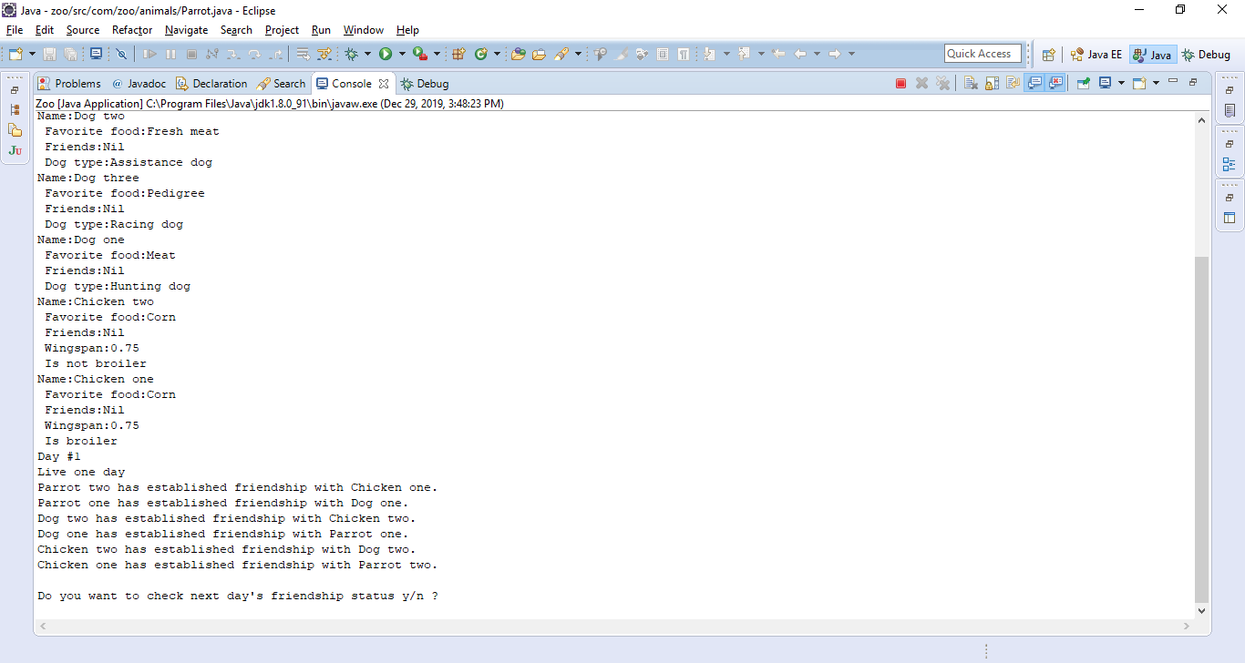

Day 2

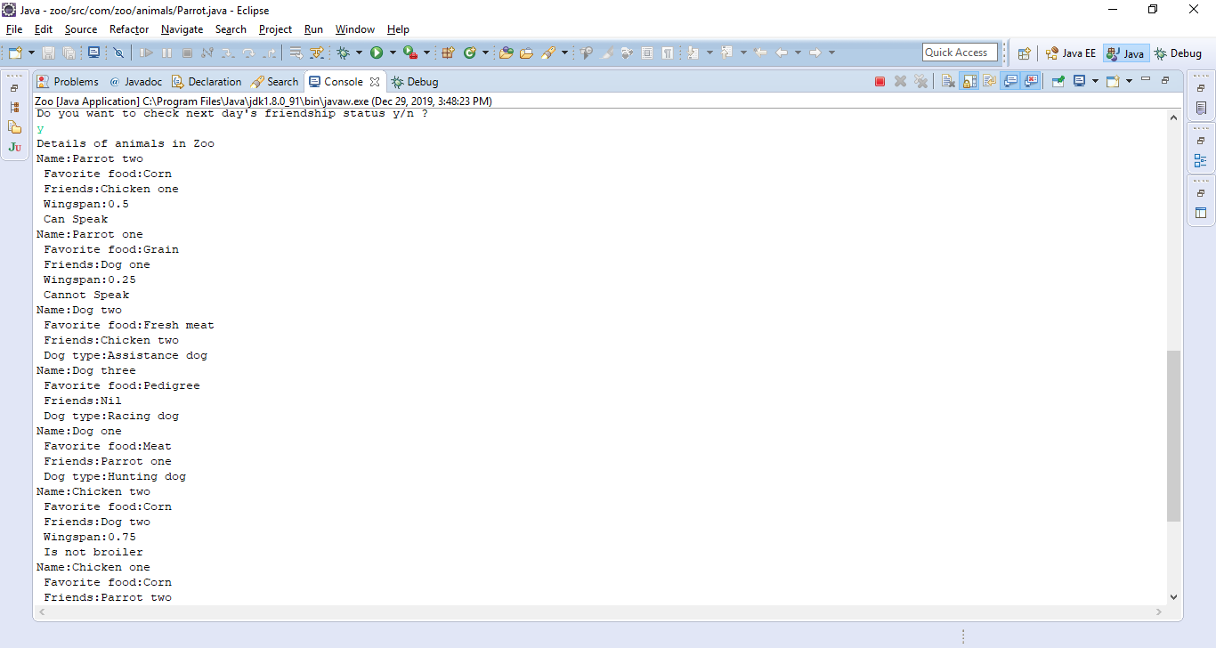

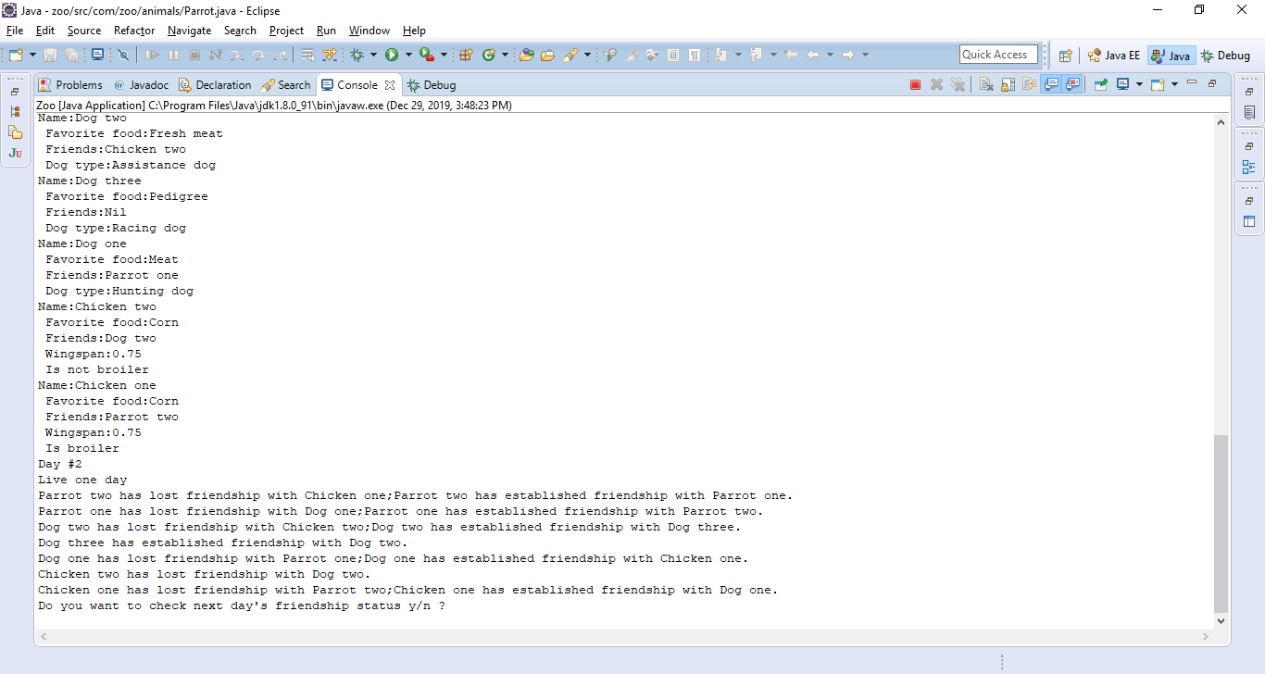

Exit

